# Issues:

## Issue 1:

# Visual Composer: - Shortcode not working. #499

I have tried in my local server, Inserted shortcode in Visual composer page builder through wordpress and have tested it. It works for me and I am sharing attachments of results in 2 images. Can you please review and let me know if any changes

## Image-1:

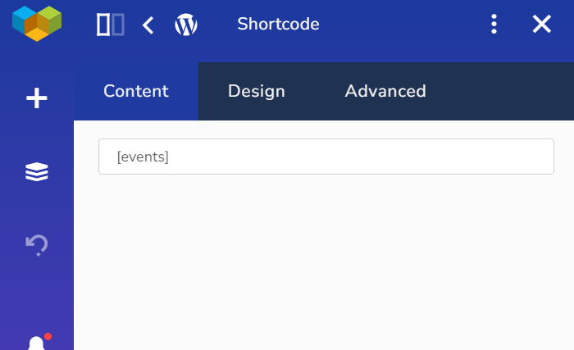

Img 1: Placed short code from our WP Event manager plugin

## Image 2:

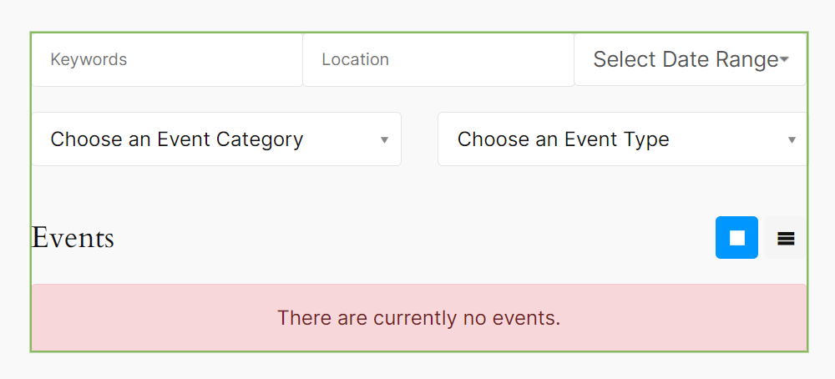

Img 2: Result after placing short code [Events] in visual composer page

## Issue2:

1. Visual composer - Event Dashboard - First time when page is load then only display one event #820

I have tested this issue and tested in my local server website, after entering all the information of event details, I have submitted listing then I have received message in event manager plugin regarding approval or reject the event, Once I approved the event automatically it was listed in event dashboard and checked in website it shows event listed in the website without any delay. It works for me perfectly no issue as far I have tested

I am sharing attachments please review and let me know any changes.

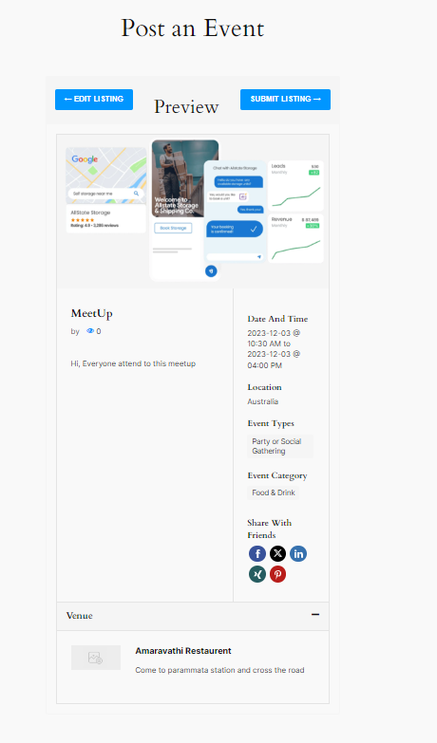

Img1 : After give info regarding event details in dashboard

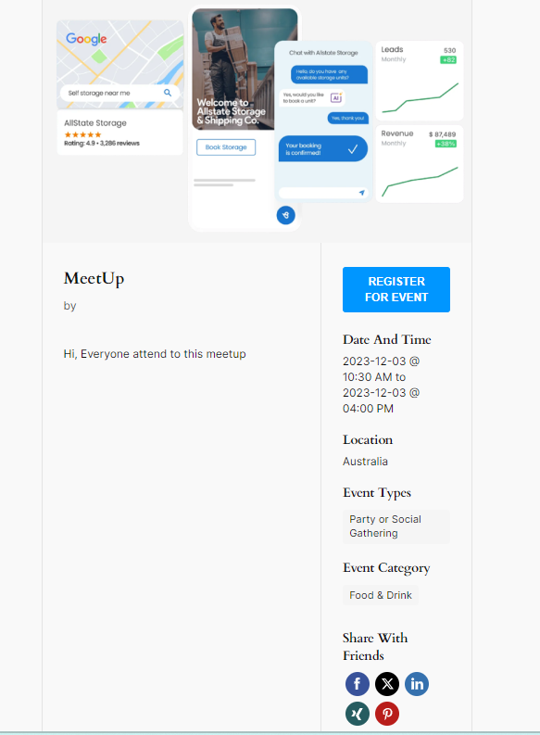

Img2: Result after approval without any delay

## Issue3:

1. In the visual composer elements are missing #992

I have tested this issue and tested in my local server website, after checking elements section in visual composer it shows elements of wp event manager in that page builder. It works for me perfectly no issue as far I have tested

I am sharing attachments please review and let me know any changes.

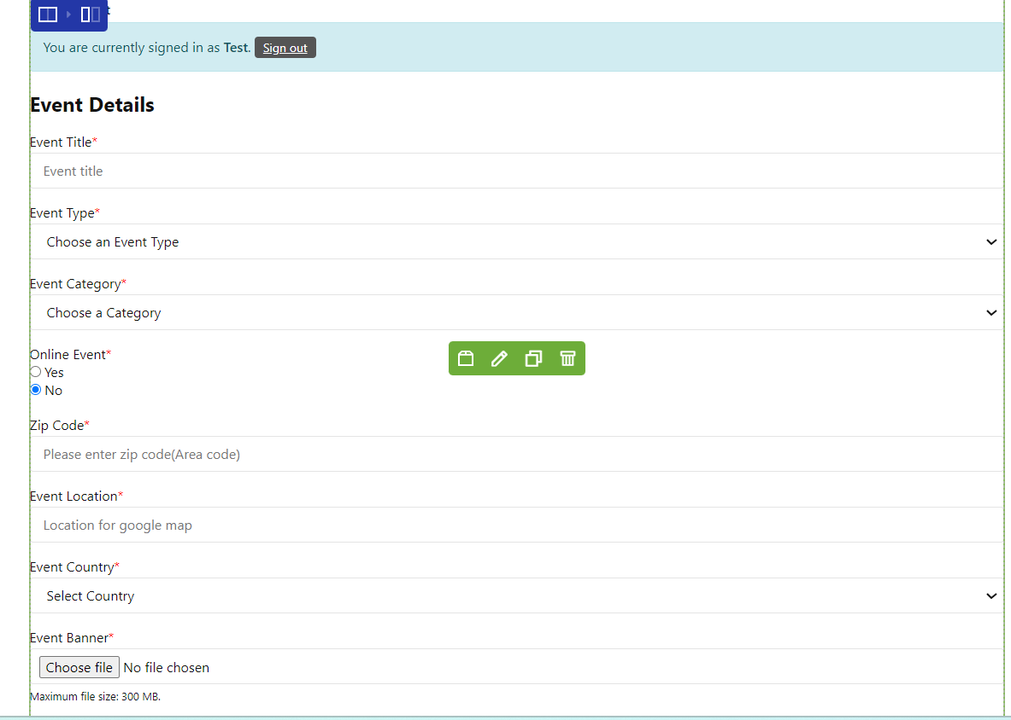

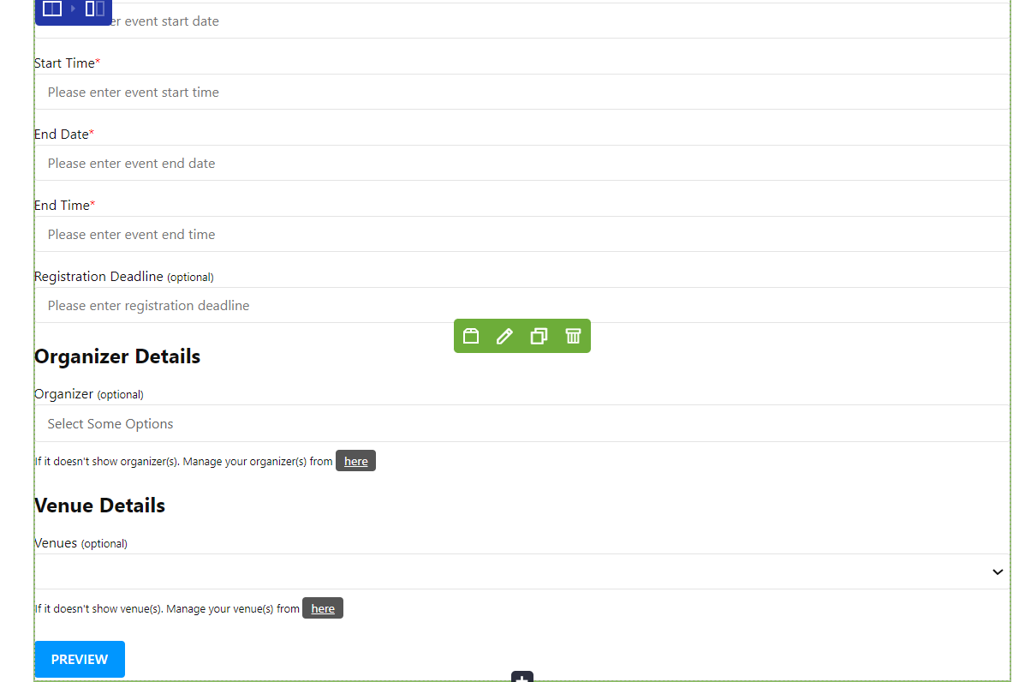

Img: After selecting an add an event element in visual composer

## Issue4:

1. Visual Composer: - Event Listing widget not working. #498

As far I have done research on this issue, I came across that sometimes widget works and sometimes it shows issue due to plugin and theme compatibility, as we see while installing plugin it shows that whether it is compatibility with our WordPress. Due to these conflicts, we face issues in widget not working. There may be also other reason some page builder will not show all the elements due to version and compatibility, for example this event listing widget not works on visual composer but it works on other page builder like Elementor because of compatibility with plugin. I have tried other widgets which works perfectly. Sometimes, themes may override or conflict with certain functionalities of page builders.

## Issue5:

1. Event Listing and other Shortcodes for Visual Editor #194

I have checked this issue in both admin panel and visual editor these shortcodes are added. I have tested each shortcode in visual editor and also in website it works perfectly, btw I have suggested some new improvements regarding plugin development in other document, please look into it and if you are happy with suggestion, I can add each new short code to our plugin and visual editor.

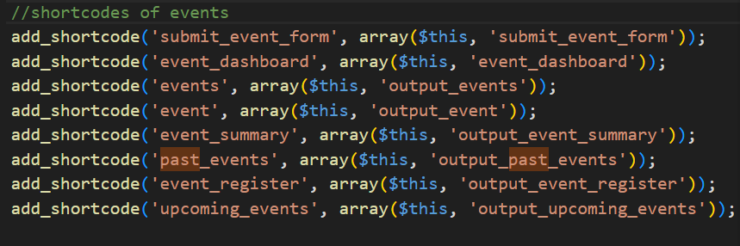

Img: Visual editor short codes regarding events

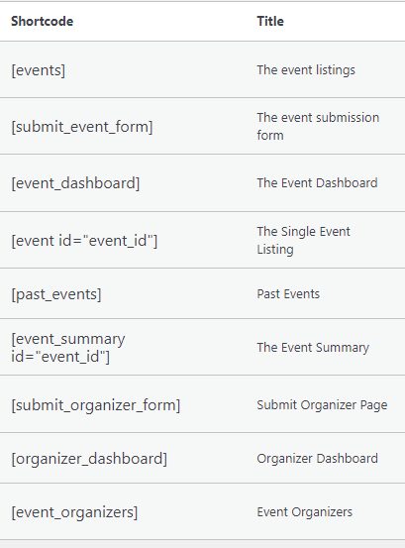

These are some Issues I have checked and tested in local server and provided feedback of each issue, Please check and let me know your feedback so that I can make changes in coding and Implement in our plugin.